Art Collections 2020, Historical Research Session (ARCO 2020, HR)

[1]

Abstract

© 2020 The Authors. Published by DIDAPRESS.  
This is an open-access article under the CC BY-NC-ND license (<http://creativecommons.org/licenses/by-nc-nd/4.0/>)

Peer-review under the responsibility of Giorgio Verdiani, Alessandro Brodini, Francesco Valerio Collotti

*Keywords:*

Here introduce the paper, and put a nome­nclature if necessary, in a box with the same font size as the rest of the paper. The paragraphs continue from here and are only separated by headings, subheadings, images and formulae. The section headings are arranged by numbers, bold and 10 pt. Here follow further instructions for authors.

* 1. Structure

Files must be in MS Word only and should be formatted for direct printing, using the CRC MS Word provided. Figures and tables should be embedded and not supplied separately.

* THE MAX SIZE OF THE DOCUMENT IS 16 PAGES (ALL INCLUSIVE OF TEXT, TITLE, NOTES, REFERENCES, IMAGES AND CAPTIONS)
* THE MINIMAL SIZE OF THE DOCUMENT IS 6 PAGES (ALL INCLUSIVE OF TEXT, TITLE, NOTES, REFERENCES, IMAGES AND CAPTIONS)
* THE MAX FILE SIZE FOR THE UPLOADED DOCX IS 20 MB – WITH ALL THE TEXT AND GRAPHICS EMBEDDED
* IN THE BALANCE TEXT/IMAGES CONSIDER THAT AT LEAST 5 PAGES OF TEXT ARE REQUIRED FOR ACCEPTANCE

Please make sure that you use as much as possible normal fonts in your documents. Special fonts, such as fonts used in the Far East (Japanese, Chinese, Korean, etc.) may cause problems during processing. To avoid unnecessary errors you are strongly advised to use the ‘spellchecker’ function of MS Word. Follow this order when typing manuscripts: Title, Authors, Affiliations, Abstract, Keywords, Main text (including figures and tables), Acknowledgements, References, Appendix. Collate acknowledgements in a separate section at the end of the article and do not include them on the title page, as a footnote to the title or otherwise.

Bulleted lists may be included and should look like this:

* First point
* Second point
* And so on

Ensure that you return to the ‘Els-body-text’ style, the style that you will mainly be used for large blocks of text, when you have completed your bulleted list.

Please do not alter the formatting and style layouts which have been set up in this template document. As indicated in the template, papers should be prepared in a single-column format suitable for direct printing onto paper with the trim size 192 x 262 mm. Do not number pages on the front, as page numbers will be added separately for the preprints and the Proceedings. Leave a line clear between paragraphs. All the required style templates are provided in the file “MS Word Template” with the appropriate name supplied, e.g. choose 1. Els1st-order-head for your first order heading text, els-abstract-text for the abstract text etc.

* 1. Tables

All tables should be numbered with Arabic numerals. Every table should have a caption. Headings should be placed above tables, left-justified. Only horizontal lines should be used within a table, to distinguish the column headings from the body of the table, and immediately above and below the table. Tables must be embedded in the text and not supplied separately. Below is an example which the authors may find useful.

Table 1. An example of a table.

|  |  |  |
| --- | --- | --- |
| An example of a column heading | Column A (*t*) | Column B (*t*) |
| And an entry | 1 | 2 |
| And another entry | 3 | 4 |
| And another entry | 5 | 6 |

* 1. Construction of references

References must be listed at the end of the paper. Do not begin them on a new page unless this is absolutely necessary. Authors should ensure that every reference in the text appears in the list of references and vice versa. Indicate references by Clark et al. (1962) or Deal and Grove (2009) or Fachinger (2006) in the text.

Some examples of how your references should be listed are given at the end of this template in the ‘References’ section, which will allow you to assemble your reference list according to the correct format and font size.

* 1. Section headings

Section headings should be left justified, bold, with the first letter capitalized and numbered consecutively, starting with the Introduction. Sub-section headings should be in capital and lower-case italic letters, numbered 1.1, 1.2, etc, and left justified, with second and subsequent lines indented. All headings should have a minimum of three text lines after them before a page or column break. Ensure the text area is not blank except for the last page.

* 1. General guidelines for the preparation of your text

Avoid hyphenation at the end of a line. Symbols denoting vectors and matrices should be indicated in bold type. Scalar variable names should normally be expressed using italics. Weights and measures should be expressed in SI units. All non-standard abbreviations or symbols must be defined when first mentioned, or a glossary provided.

* 1. File naming and delivery

Please title your files in this order ‘arco_TA4_SHORT_TITLE_authorslastname’. Submit the source file and the optional PDF to the Guest Editor.

* 1. Footnotes

Footnotes should be avoided if possible. Necessary footnotes should be denoted in the text by consecutive superscript letters[2]1. The footnotes should be typed single-spaced, and in smaller type size (8 pt), at the foot of the page in which they are mentioned, and separated from the main text by a one-line space extending at the foot of the column. The Els-footnote style is available in the MS Word for the text of the footnote.

Please do not change the margins of the template as this can result in the footnote falling outside printing range.

1. Illustrations

All figures should be numbered with Arabic numerals (1,2,3,….). Every figure should have a caption. All photographs, schemas, graphs and diagrams are to be referred to as figures. Line drawings should be good quality scans or true electronic output. Low-quality scans are not acceptable. Figures must be embedded in the text and not supplied separately. In MS word input the figures must be properly coded. The preferred format for figures is PNG, JPEG, GIF etc. Lettering and symbols should be clearly defined either in the caption or in a legend provided as part of the figure. Figures should be placed at the top or bottom of a page wherever possible, as close as possible to the first reference to them in the paper. Please ensure that all the figures are of 300 DPI resolutions as this will facilitate good output.

The figure number and caption should be typed below the illustration in 8 pt and left-justified [***Note:*** one-line captions of length less than the column width (or full typesetting width or oblong) centred]. The artwork should have no text along the side of it in the main body of the text. However, if two images fit next to each other, these may be placed next to each other to save space.

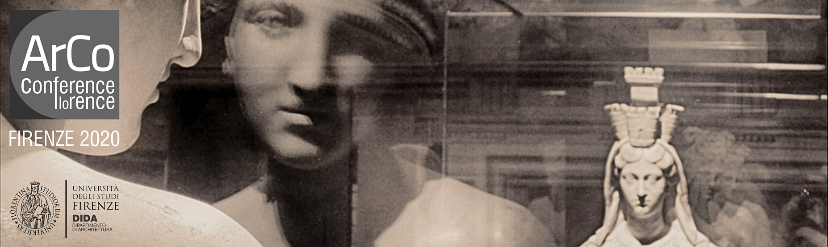

Fig. 1. Picture from the Arco Conference

1. Equations

Equations and formulae should be typed in MathType, and numbered consecutively with Arabic numerals in parentheses on the right hand side of the page (if referred to explicitly in the text). They should also be separated from the surrounding text by one space.

(1)

4. Online license transfer

All authors filling the online submission form accept the exclusive DIDAPRESS license transfer agreement before the article can be published. This transfer agreement enables DIDAPRESS to protect the copyrighted material for the authors but does not relinquish the authors’ proprietary rights. The copyright transfer covers the exclusive rights to reproduce and distribute the article, including reprints, photographic reproductions, microfilm or any other reproductions of similar nature and translations. Authors are responsible for obtaining from the copyright holder, the permission to reproduce any figures for which copyright exists.

Acknowledgements

Acknowledgements and Reference heading should be left justified, bold, with the first letter capitalized but have no numbers. Text below continues as normal.

References

Clark, T., Woodley, R., De Halas, D., 1962. Gas-Graphite Systems, in *“Nuclear Graphite”.* In: Nightingale, R. (Ed.). Academic Press,   
New York, pp. 387.

Deal, B., Grove, A., 1965. General Relationship for the Thermal Oxidation of Silicon. Journal of Applied Physics 36, 37–70.

Deep-Burn Project: Annual Report for 2009, Idaho National Laboratory, Sept. 2009.

Fachinger, J., den Exter, M., Grambow, B., Holgerson, S., Landesmann, C., Titov, M., Podruhzina, T., 2004. Behavior of spent HTR fuel elements in aquatic phases of repository host rock formations, 2nd International Topical Meeting on High Temperature Reactor Technology. Beijing, China, paper #B08.

Fachinger, J., 2006. Behavior of HTR Fuel Elements in Aquatic Phases of Repository Host Rock Formations. Nuclear Engineering & Design 236, 54.

1. * Corresponding author. Tel.: ; fax: .

   *E-mail address:*
2. 1 Footnote text.